Jack Melcher

67574625

EECS 117

HW1 Part2



Figure 1: Mandelbrot Set with a 1024 x 1024 image size

Which do you think is better? Why? Which intern do you offer a full-time job?

Susie‘s method is better as it will distribute the work more evenly between each core than Joe’s method. Joe’s method may give a core a block of rows that have greater number of times that iterate to 511 than others. I would offer Susie a full-time job.

Implement Susie and Joe’s approaches in the respective files called mandelbrot_susie.cc and mandelbrot_joe.cc. Use at least up to the maximum 64 processes on the class queue and more on the public queues if you wish and an image size of your choice. Analyze the speedup and efficiency of the two approaches against the provided serial version. Submit the plots and a discussion of your results.

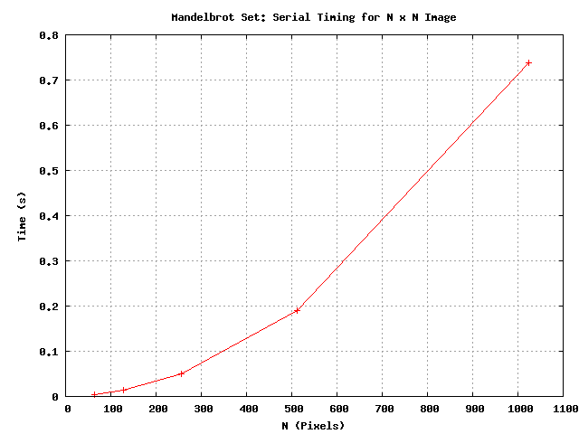

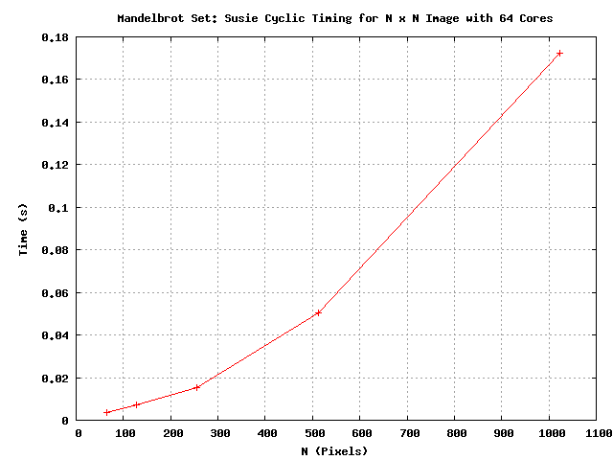

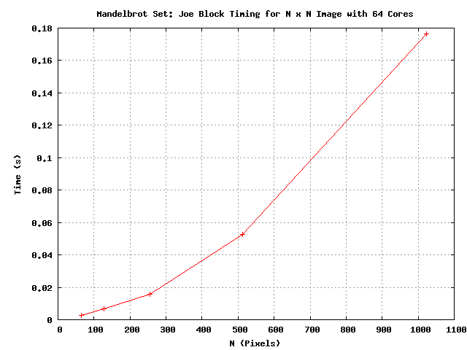

Both Joe’s and Susie’s had a speed up of approximately S = 4 times that of the serial version for calculating a Mandelbrot set. Joe’s and Susie’s implementations also shows a parallel efficiency E = S/p = 4/64 = 1/16. I think Susie’s implementation will scale better for very large image sizes because, as explained in my previous answer, it will more evenly distribute the work to each core.

Implement the Mandelbrot image computation using a master/slave MPI strategy in mandelbrot_ms.cc where a job is defined as computing a row of the image. Communicate as little as possible. Compare the master/slave strategy with Susie/Joe’s implementation. Which do you think will scale to very large image sizes? Why?

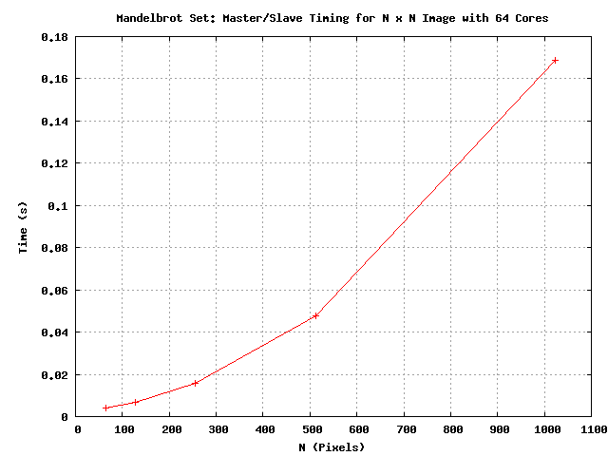

Even though my plots show that master/slave out performs Susie’s method, I still think Susie’s scale better than master /slave at very large image sizes. The master slave model requires a lot more communication, and that will have a greater impact on time as the image size becomes very large.